Y2Q4W1

Sermon on the Mount, Woman at the well

Where's Wally: See how quickly you can find Wally

Ask: What makes Wally hard to find?
Ask: What would make him easier to find?
Say: Wally is hard to find because he looks similar to everyone else.

Bible Story

Say: Jesus wanted people to be kind and loving and happy.
Show: The pictures
Ask: Would Jesus like what this boy/girl is doing? What are they doing? Why would Jesus like it?

Sing Songs

Return to tables
Memory Verse: Fill in the blanks and then say the memory verse on the colouring page.

Say: This term we are going to make a special box and each week we will get a card to put in it.

Older Children: Can decoupage their box. See decoupage instructions on the internet but basically, put a dab of glue under the paper to be glued on and put a small amount on top as well. Put your finger in the glue on top and starting at the middle smooth towards the edges until the paper is firmly pressed down and covered with glue, and any bubbles are pressed out. Children may use scraps of paper to add coloured backgrounds if desired.

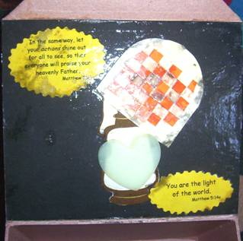
Craft:
- Get a box and put your name on it
- On the inside of the lid, use coloured paper to make a background if desired.
- Add the lantern and glue or tape a glow-in–the-dark sticker on it
- Weave strips of coloured paper through the "basket" and tape or glue them on the back
- Glue the basket above lantern
- For older children / if there is space, glue on the Bible verses.
- Note: To avoid blotching when you eventually varnish, make sure both sides of everything has been covered with glue – the glue acts as a sealer.

Discuss the following depending on age, interest and time:
Discuss the various things that Jesus said in the Sermon on the Mount
How do you think Christians should be different from other people?
What does our Bible verse mean?
Was Jesus talking about normal water to the woman at the well?
What is spiritual thirst?

Handout: The cards; cross out the things that Jesus wouldn't like and colour in the things that he would. The cards will be kept in the boxes.

Younger Children: Use toys to practice obeying by packing up and sharing. – could do it like a game of Simon Says.
Ask: Does Jesus want Christians to be different from other people? How?
Ask: Is it always easy to be a Christian?
Ask: What can we do to help us be better Christians?
Finish with prayer at each table. Pray the prayer on the card.

